**Report of Role wise task Description for Registration of Employer for Migrant Labour Service.**

|  |  |  |  |
| --- | --- | --- | --- |
| **Sl. No.** | **Role Name** | **Task Name** | **Task Description** |
| 1. | **Executive Officer** |  |  |
| 1a | TM-2 | Verification Application by Executive Officer | Executive Officer scrutinise the application.  If everything is okay then Executive Officer (Sl. No.- 1b) with Delivers **for Registration of Employer for Migrant Labour** and Update Database.  Otherwise forward to applicant (Sl. No. -2b) for Shortfall for Document.  Or Rejects (Sl. No. -1d). |
| 1b | TM-3 | Issuance Certificate by Executive Officer | Executive Officer approves delivers and generate the list of employee. |
| 1c | TM-4 | Rejection | Executive Officer Rejects the Application by giving Remarks. |
| 3. | **Applicant** |  |  |
| 2a | TM-1 | Application Submission | Applicant apply and submit the Application to Executive Officer (Sl. no.-1a.) |
| 2b | TM-5 | Applicant Submission Shortfall | Applicant submit the Application with document to Executive Officer (Sl. no.-2a.) for Shortfall. |

Table of Task Mapping – TM

**Table of Task Mapping:-**

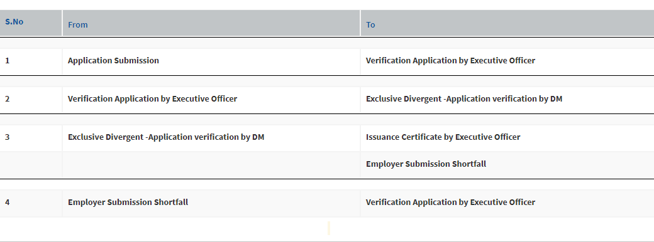

Service Plus Generated Flow Chart:

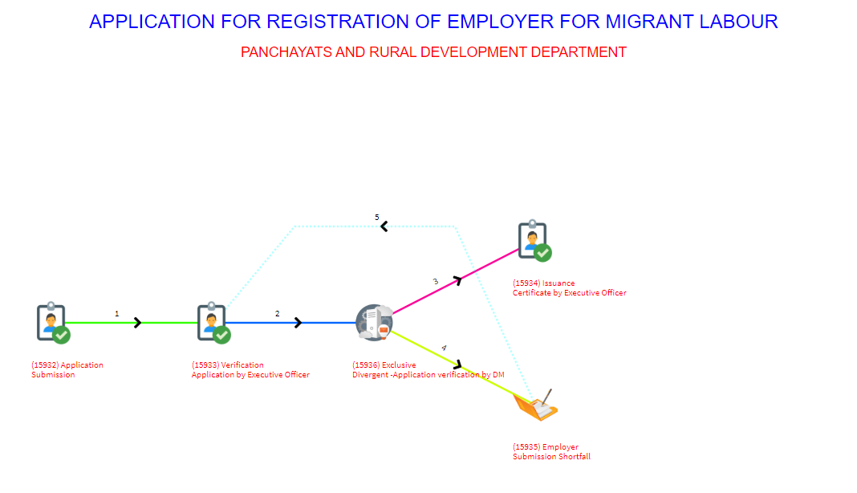

**Flow Chart for Application for Registration of Employer for Migrant Labour**

***Flow Diagram***

**DM OFFICE SECTION**

*Employer*

**1.Employer registers their organization and submits their requirement of labour (No, skill set) .**

**2. Short Fall.**

**3.Application approval.**

API-1 Call to save the detail in database

**DM OFFICE SECTION**

**4.Allotment of labour to employer and generating certificate**

API-2 Call to search for labour and update related tables

*Employer*

END

**Description**

**STEP 1:** The application will be filled online by the Employer.

**STEP 2:** Office section validates the information and if any shortfall in document than send back to employer for resubmitting the document.

**STEP 3:** Office section will approve the application.

**API 1 Call-SP send JSON (application details and labor requirement details which are-: typ_of_org,** **org_id_proof,** **addr_of_org,** **phn_no,** **email,** **identity_no,** **designation,** **app_ref_no,** **phn_of_cntct_prsn,** **org_nm,** **email_contct_prsn,** **num_of_manpwr,** **nm_of_cntct_prsn,** **name_of_work) and Portal send response(status- 0 for unsuccessful and 1- for successful updation in database).**

**STEP 4:** Office section will allot labour to an employer and generated certificate issued to employer. The certificate has labour details. The service for this particular Employer application will be deliver and closed.

**API-2 Call to search for labour and update related tables and Call-SP send JSON (INPUT-:app_ref_no)and (OUPUT-: labour_name,father_husband_name,phone_no,block,res_address,age,skill,identification_no,app_ref_no) Portal send response(status- 2 for no required labour found and 1- for successful list from database and 3- for invalid app_ref_no).**